time-logging

Image2.png

Table of Contents

Modello di Dominio

Table of Figures

Modello di Dominio

Class Diagram

# Modello di Dominio

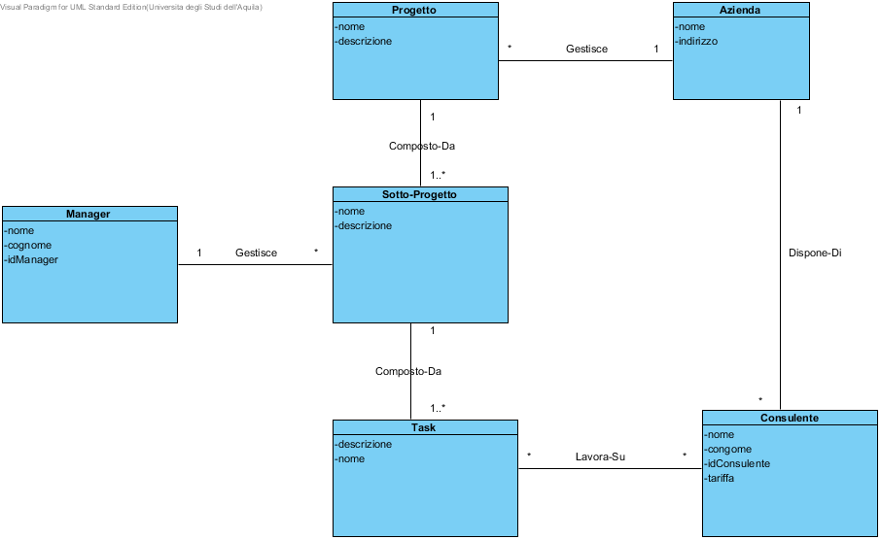

|  |  |
| --- | --- |
| **Name** | **Value** |
| Name | Modello di Dominio |
| Create Date Time | 28-ott-2013 15.52.26 |
| Last Modified | 10-dic-2013 16.30.27 |

## Summary

|  |  |
| --- | --- |
| **Name** | **Documentation** |
| Image1.png Progetto |  |
| Image1.png Azienda |  |
| Image1.png Sotto-Progetto |  |
| Image1.png Manager |  |
| Image1.png Consulente |  |
| Image1.png Task |  |

## Details

### Image1.png Progetto

|  |  |
| --- | --- |
| **Name** | **Value** |
| Author | Luca |
| Create Date Time | 28-ott-2013 16.00.56 |
| Last Modified | 18-dic-2013 11.56.07 |
| Active | false |
| Business Key Mutable | true |
| Orm Detail | N/A |
| Business Model | false |
| Visibility | public |
| Leaf | false |
| Root | false |

#### Attributes

|  |  |  |  |
| --- | --- | --- | --- |
| **private nome** | | | |
| Author | Luca | | |
| Create Date Time | 28-ott-2013 16.09.45 | | |
| Last Modified | 18-dic-2013 11.56.06 | | |
| Allow Empty Name | false | | |
| Getter | false | Setter | false |
| Derived | false | | |
| Multiplicity | Unspecified | | |
| Aggregation | None | | |
| Derived Union | false | | |
| Read Only | false | | |
| Is ID | false | | |
| Leaf | false | | |

|  |  |  |  |
| --- | --- | --- | --- |
| **private descrizione** | | | |
| Author | Luca | | |
| Create Date Time | 28-ott-2013 16.09.46 | | |
| Last Modified | 18-dic-2013 11.56.06 | | |
| Allow Empty Name | false | | |
| Getter | false | Setter | false |
| Derived | false | | |
| Multiplicity | Unspecified | | |
| Aggregation | None | | |
| Derived Union | false | | |
| Read Only | false | | |
| Is ID | false | | |
| Leaf | false | | |

|  |  |  |  |
| --- | --- | --- | --- |
| **private sottoProgetti : Sotto-Progetto** | | | |
| Author | Luca | | |
| Create Date Time | 29-ott-2013 15.55.25 | | |
| Last Modified | 18-dic-2013 11.56.07 | | |
| Type Modifier | [] | | |
| Type | Image1.png Sotto-Progetto | | |
| Allow Empty Name | false | | |
| Getter | false | Setter | false |
| Derived | false | | |
| Multiplicity | Unspecified | | |
| Aggregation | None | | |
| Derived Union | false | | |
| Read Only | false | | |
| Is ID | false | | |
| Leaf | false | | |

#### ORM Class Detail

|  |  |
| --- | --- |
| **Name** | **Value** |
| Read Only | false |
| Lazy | false |
| Cache | Disable |
| Inheritance Strategy | Per class |
| Reference | false |

### Image1.png Azienda

|  |  |
| --- | --- |
| **Name** | **Value** |
| Author | Luca |
| Create Date Time | 28-ott-2013 16.00.51 |
| Last Modified | 18-dic-2013 11.56.07 |
| Active | false |
| Business Key Mutable | true |
| Orm Detail | N/A |
| Business Model | false |
| Visibility | public |
| Leaf | false |
| Root | false |

#### Attributes

|  |  |  |  |
| --- | --- | --- | --- |
| **private nome** | | | |
| Author | Luca | | |
| Create Date Time | 28-ott-2013 16.09.55 | | |
| Last Modified | 18-dic-2013 11.56.06 | | |
| Allow Empty Name | false | | |
| Getter | false | Setter | false |
| Derived | false | | |
| Multiplicity | Unspecified | | |
| Aggregation | None | | |
| Derived Union | false | | |
| Read Only | false | | |
| Is ID | false | | |
| Leaf | false | | |

|  |  |  |  |
| --- | --- | --- | --- |
| **private indirizzo** | | | |
| Author | Luca | | |
| Create Date Time | 28-ott-2013 16.09.57 | | |
| Last Modified | 18-dic-2013 11.56.06 | | |
| Allow Empty Name | false | | |
| Getter | false | Setter | false |
| Derived | false | | |
| Multiplicity | Unspecified | | |
| Aggregation | None | | |
| Derived Union | false | | |
| Read Only | false | | |
| Is ID | false | | |
| Leaf | false | | |

#### ORM Class Detail

|  |  |
| --- | --- |
| **Name** | **Value** |
| Read Only | false |
| Lazy | false |
| Cache | Disable |
| Inheritance Strategy | Per class |
| Reference | false |

### Image1.png Sotto-Progetto

|  |  |
| --- | --- |
| **Name** | **Value** |
| Author | Luca |
| Create Date Time | 28-ott-2013 15.53.23 |
| Last Modified | 18-dic-2013 11.56.07 |
| Active | false |
| Business Key Mutable | true |
| Orm Detail | N/A |
| Business Model | false |
| Visibility | public |
| Leaf | false |
| Root | false |

#### Attributes

|  |  |  |  |
| --- | --- | --- | --- |
| **private nome** | | | |
| Author | Luca | | |
| Create Date Time | 28-ott-2013 16.09.32 | | |
| Last Modified | 18-dic-2013 11.56.06 | | |
| Allow Empty Name | false | | |
| Getter | false | Setter | false |
| Derived | false | | |
| Multiplicity | Unspecified | | |
| Aggregation | None | | |
| Derived Union | false | | |
| Read Only | false | | |
| Is ID | false | | |
| Leaf | false | | |

|  |  |  |  |
| --- | --- | --- | --- |
| **private descrizione** | | | |
| Author | Luca | | |
| Create Date Time | 28-ott-2013 16.09.34 | | |
| Last Modified | 18-dic-2013 11.56.06 | | |
| Allow Empty Name | false | | |
| Getter | false | Setter | false |
| Derived | false | | |
| Multiplicity | Unspecified | | |
| Aggregation | None | | |
| Derived Union | false | | |
| Read Only | false | | |
| Is ID | false | | |
| Leaf | false | | |

#### ORM Class Detail

|  |  |
| --- | --- |
| **Name** | **Value** |
| Read Only | false |
| Lazy | false |
| Cache | Disable |
| Inheritance Strategy | Per class |
| Reference | false |

### Image1.png Manager

|  |  |
| --- | --- |
| **Name** | **Value** |
| Author | Luca |
| Create Date Time | 28-ott-2013 15.52.46 |
| Last Modified | 18-dic-2013 11.56.07 |
| Active | false |
| Business Key Mutable | true |
| Orm Detail | N/A |
| Business Model | false |
| Visibility | public |
| Leaf | false |
| Root | false |

#### Attributes

|  |  |  |  |
| --- | --- | --- | --- |
| **private nome** | | | |
| Author | Luca | | |
| Create Date Time | 28-ott-2013 16.09.07 | | |
| Last Modified | 18-dic-2013 11.56.06 | | |
| Allow Empty Name | false | | |
| Getter | false | Setter | false |
| Derived | false | | |
| Multiplicity | Unspecified | | |
| Aggregation | None | | |
| Derived Union | false | | |
| Read Only | false | | |
| Is ID | false | | |
| Leaf | false | | |

|  |  |  |  |
| --- | --- | --- | --- |
| **private cognome** | | | |
| Author | Luca | | |
| Create Date Time | 28-ott-2013 16.09.11 | | |
| Last Modified | 18-dic-2013 11.56.06 | | |
| Allow Empty Name | false | | |
| Getter | false | Setter | false |
| Derived | false | | |
| Multiplicity | Unspecified | | |
| Aggregation | None | | |
| Derived Union | false | | |
| Read Only | false | | |
| Is ID | false | | |
| Leaf | false | | |

|  |  |  |  |
| --- | --- | --- | --- |
| **private idManager** | | | |
| Author | lucfino | | |
| Create Date Time | 12-dic-2013 11.40.56 | | |
| Last Modified | 18-dic-2013 11.56.06 | | |
| Allow Empty Name | false | | |
| Getter | false | Setter | false |
| Derived | false | | |
| Multiplicity | Unspecified | | |
| Aggregation | None | | |
| Derived Union | false | | |
| Read Only | false | | |
| Is ID | false | | |
| Leaf | false | | |

#### ORM Class Detail

|  |  |
| --- | --- |
| **Name** | **Value** |
| Read Only | false |
| Lazy | false |
| Cache | Disable |
| Inheritance Strategy | Per class |
| Reference | false |

### Image1.png Consulente

|  |  |
| --- | --- |
| **Name** | **Value** |
| Author | Luca |
| Create Date Time | 28-ott-2013 15.53.49 |
| Last Modified | 18-dic-2013 11.56.07 |
| Active | false |
| Business Key Mutable | true |
| Orm Detail | N/A |
| Business Model | false |
| Visibility | public |
| Leaf | false |
| Root | false |

#### Attributes

|  |  |  |  |
| --- | --- | --- | --- |
| **private nome** | | | |
| Author | Luca | | |
| Create Date Time | 28-ott-2013 16.09.23 | | |
| Last Modified | 18-dic-2013 11.56.06 | | |
| Allow Empty Name | false | | |
| Getter | false | Setter | false |
| Derived | false | | |
| Multiplicity | Unspecified | | |
| Aggregation | None | | |
| Derived Union | false | | |
| Read Only | false | | |
| Is ID | false | | |
| Leaf | false | | |

|  |  |  |  |
| --- | --- | --- | --- |
| **private congome** | | | |
| Author | Luca | | |
| Create Date Time | 28-ott-2013 16.09.25 | | |
| Last Modified | 18-dic-2013 11.56.06 | | |
| Allow Empty Name | false | | |
| Getter | false | Setter | false |
| Derived | false | | |
| Multiplicity | Unspecified | | |
| Aggregation | None | | |
| Derived Union | false | | |
| Read Only | false | | |
| Is ID | false | | |
| Leaf | false | | |

|  |  |  |  |
| --- | --- | --- | --- |
| **private idConsulente** | | | |
| Author | Luca | | |
| Create Date Time | 28-ott-2013 16.56.31 | | |
| Last Modified | 18-dic-2013 11.56.06 | | |
| Allow Empty Name | false | | |
| Getter | false | Setter | false |
| Derived | false | | |
| Multiplicity | Unspecified | | |
| Aggregation | None | | |
| Derived Union | false | | |
| Read Only | false | | |
| Is ID | false | | |
| Leaf | false | | |

|  |  |  |  |
| --- | --- | --- | --- |
| **private tariffa** | | | |
| Author | lucfino | | |
| Create Date Time | 11-dic-2013 16.34.07 | | |
| Last Modified | 18-dic-2013 11.56.06 | | |
| Allow Empty Name | false | | |
| Getter | false | Setter | false |
| Derived | false | | |
| Multiplicity | Unspecified | | |
| Aggregation | None | | |
| Derived Union | false | | |
| Read Only | false | | |
| Is ID | false | | |
| Leaf | false | | |

#### ORM Class Detail

|  |  |
| --- | --- |
| **Name** | **Value** |
| Read Only | false |
| Lazy | false |
| Cache | Disable |
| Inheritance Strategy | Per class |
| Reference | false |

### Image1.png Task

|  |  |
| --- | --- |
| **Name** | **Value** |
| Author | Luca |
| Create Date Time | 28-ott-2013 15.53.59 |
| Last Modified | 18-dic-2013 11.56.07 |
| Active | false |
| Business Key Mutable | true |
| Orm Detail | N/A |
| Business Model | false |
| Visibility | public |
| Leaf | false |
| Root | false |

#### Attributes

|  |  |  |  |
| --- | --- | --- | --- |
| **private descrizione** | | | |
| Author | Luca | | |
| Create Date Time | 28-ott-2013 16.10.25 | | |
| Last Modified | 18-dic-2013 11.56.06 | | |
| Allow Empty Name | false | | |
| Getter | false | Setter | false |
| Derived | false | | |
| Multiplicity | Unspecified | | |
| Aggregation | None | | |
| Derived Union | false | | |
| Read Only | false | | |
| Is ID | false | | |
| Leaf | false | | |

|  |  |  |  |
| --- | --- | --- | --- |
| **private nome** | | | |
| Author | lucfino | | |
| Create Date Time | 12-dic-2013 11.41.09 | | |
| Last Modified | 18-dic-2013 11.56.06 | | |
| Allow Empty Name | false | | |
| Getter | false | Setter | false |
| Derived | false | | |
| Multiplicity | Unspecified | | |
| Aggregation | None | | |
| Derived Union | false | | |
| Read Only | false | | |
| Is ID | false | | |
| Leaf | false | | |

#### ORM Class Detail

|  |  |
| --- | --- |
| **Name** | **Value** |
| Read Only | false |
| Lazy | false |
| Cache | Disable |
| Inheritance Strategy | Per class |
| Reference | false |